Task1:
Aim: To find the maximum sum of a contiguous subarray from a given integer array using an efficient approach (Kadane’s Algorithm).
Algorithm:
1 Start.
2 Initialize:
- maxSum = Integer.MIN_VALUE
- currentSum = 0
3 Traverse the array from index 0 to n-1.
4 Add the current element to currentSum.
5 If currentSum is greater than maxSum, update maxSum.
6 If currentSum becomes negative, reset currentSum to 0.
7 Repeat steps 4–6 until the array ends.
8 Return maxSum.
9 Stop.
Program:
class Solution {
public int maxSubArray(int[] nums) {
int maxSum = Integer.MIN_VALUE;
int currentSum = 0;
for (int i = 0; i < nums.length; i++) {
currentSum += nums[i];
if (currentSum > maxSum) {
maxSum = currentSum;
}
if (currentSum < 0) {
currentSum = 0;
}
}
return maxSum;
}
Output:
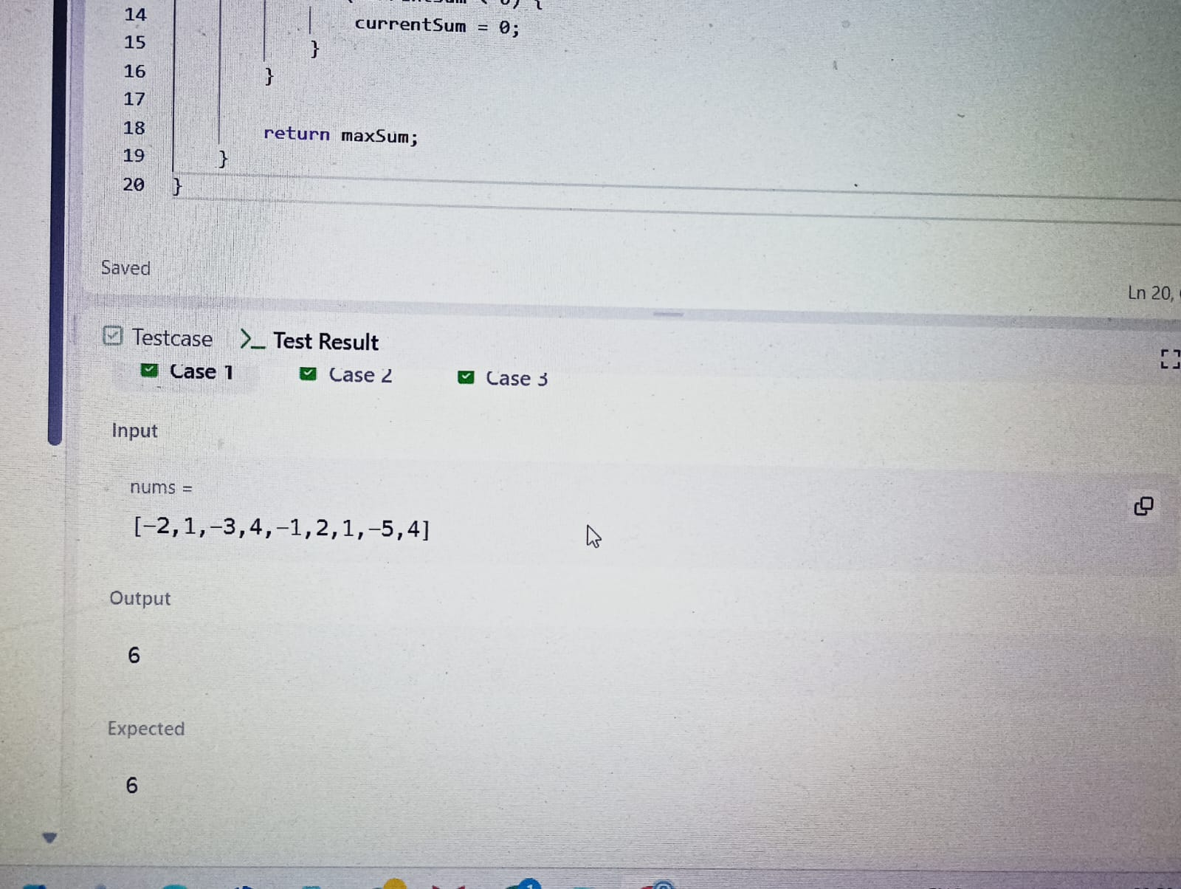

Result: The program returns the maximum sum of any contiguous subarray present in the given array.

Task2:
Aim: To determine the number of contiguous segments of length m in a chocolate bar such that the sum of integers in that segment equals d (Ron's birthday problem).
Algorithm:
1 Start.
2 Input:
- n → number of chocolate squares
- List s → integers on each square
- d → Ron’s birth day (required sum)
- m → Ron’s birth month (segment length)
3 Initialize count = 0.
4 Loop from index i = 0 to s.size() - m:
- Initialize sum = 0.
- For j = 0 to m - 1:
  - Add s.get(i + j) to sum.
- If sum == d, increment count.
5 After checking all possible segments, return count.
6 Print the result.
7 Stop.
Program:
import java.util.*;
public class BirthdayChocolate {
static int birthday(List<Integer> s, int d, int m) {
int count = 0;
for (int i = 0; i <= s.size() - m; i++) {
int sum = 0;
for (int j = 0; j < m; j++) {
sum += s.get(i + j);
}
if (sum == d) {
count++;
}
}
return count;
}
public static void main(String[] args) {
Scanner scanner = new Scanner(System.in);
int n = scanner.nextInt(); // number of squares
List<Integer> s = new ArrayList<>();
for (int i = 0; i < n; i++) {
s.add(scanner.nextInt());
}

int d = scanner.nextInt();
int m = scanner.nextInt();
int result = birthday(s, d, m);
System.out.println(result);
scanner.close();
}
}

Output:
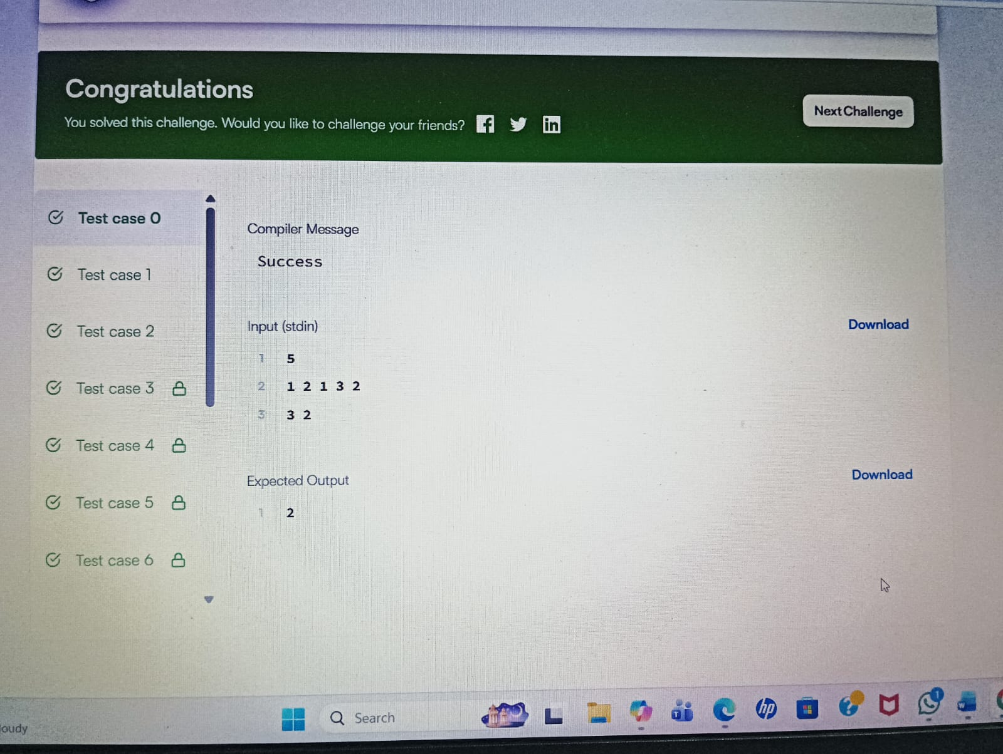

Result: The program prints the number of ways the chocolate bar can be divided into contiguous segments of length m such that the sum equals d.

Task3:
Aim: To find:
- Maximum Subarray Sum (maximum sum of contiguous elements).
- Maximum Subsequence Sum (maximum sum of non-contiguous elements).
Algorithm:
- Initialize:
  - maxSubarray = arr[0]
  - currentSum = arr[0]
- Traverse the array from index 1 to n-1.
- For each element:
  - currentSum = max(arr[i], currentSum + arr[i])
  - maxSubarray = max(maxSubarray, currentSum)
- At the end, maxSubarray contains the maximum contiguous subarray sum.
Program:
import java.util.*;
public class MaxSubarraySum {
static int[] maxSubarray(int[] arr) {
int n = arr.length;
int maxSubarray = arr[0];
int currentSum = arr[0];
for (int i = 1; i < n; i++) {
currentSum = Math.max(arr[i], currentSum + arr[i]);
maxSubarray = Math.max(maxSubarray, currentSum);
}
int maxSubsequence = 0;
boolean hasPositive = false;
for (int num : arr) {
if (num > 0) {
maxSubsequence += num;
hasPositive = true;
}
}
if (!hasPositive) {
maxSubsequence = Arrays.stream(arr).max().getAsInt();
}
return new int[]{maxSubarray, maxSubsequence};
}
public static void main(String[] args) {
Scanner scanner = new Scanner(System.in);
int t = scanner.nextIn
while (t-- > 0) {
int n = scanner.nextInt();
int[] arr = new int[n];
for (int i = 0; i < n; i++) {
arr[i] = scanner.nextInt();
}
int[] result = maxSubarray(arr);
System.out.println(result[0] + " " + result[1]);
}
scanner.close();
}
Output:
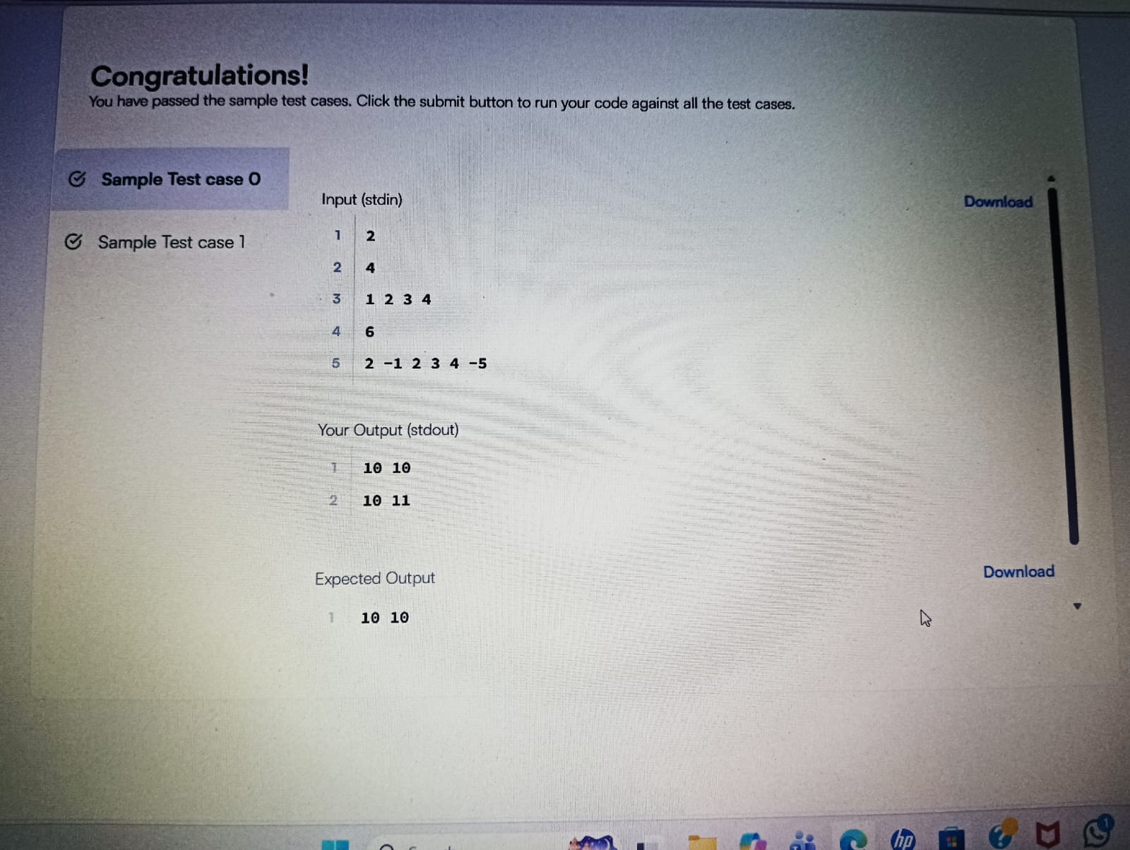

Result: The program outputs two values for each test case:
Maximum_Subarray_Sum Maximum_Subsequence_Sum
- Maximum Subarray Sum → Largest sum of contiguous elements.
- Maximum Subsequence Sum → Largest sum of non-contiguous elements.

Task4:
Aim: To find the maximum sum of a circular subarray in a given integer array using Kadane’s Algorithm.
Algorithm:
Step 1: Calculate Total Sum
- Initialize totalSum = 0.
- Traverse the array and add all elements to totalSum.

🔹 Step 2: Find Maximum Subarray Sum (Normal Kadane)
- Initialize:
  - max = Integer.MIN_VALUE
  - currSum = 0
- Traverse array:
  - If currSum < 0, reset it to 0.
  - Add current element to currSum.
  - Update max = Math.max(max, currSum).
- Store result in maxSum.

🔹 Step 3: Find Minimum Subarray Sum
- Initialize:
  - min = Integer.MAX_VALUE
  - currSum = 0
- Traverse array:
  - If currSum > 0, reset it to 0.
  - Add current element to currSum.
  - Update min = Math.min(min, currSum).
- Store result in minSum.

🔹 Step 4: Find Circular Maximum Sum
- circularSum = totalSum - minSum
- If maxSum <= 0 (all numbers are negative), return maxSum.
- Otherwise, return Math.max(maxSum, circularSum)
Program:
class Solution {
public int maxKadane(int[] nums){
int max = Integer.MIN_VALUE;
int currSum = 0;
for(int i=0; i<nums.length; i++){
if(currSum<0) currSum = 0;
currSum += nums[i];
max = Math.max(max, currSum);
}
return max;
}
public int minKadane(int[] nums){
int min = Integer.MAX_VALUE;
int currSum = 0;
for(int i=0; i<nums.length; i++){
if(currSum>0) currSum = 0;
currSum += nums[i];
min = Math.min(min, currSum);
}
return min;
}
public int maxSubarraySumCircular(int[] nums) {
int n = nums.length;
int totalSum = 0;
for(int a : nums) totalSum += a;
int maxSum = maxKadane(nums);
int minSum = minKadane(nums);
int cirSum = totalSum - minSum;
if(maxSum<=0) return maxSum;
return Math.max(maxSum, cirSum);
}
Output: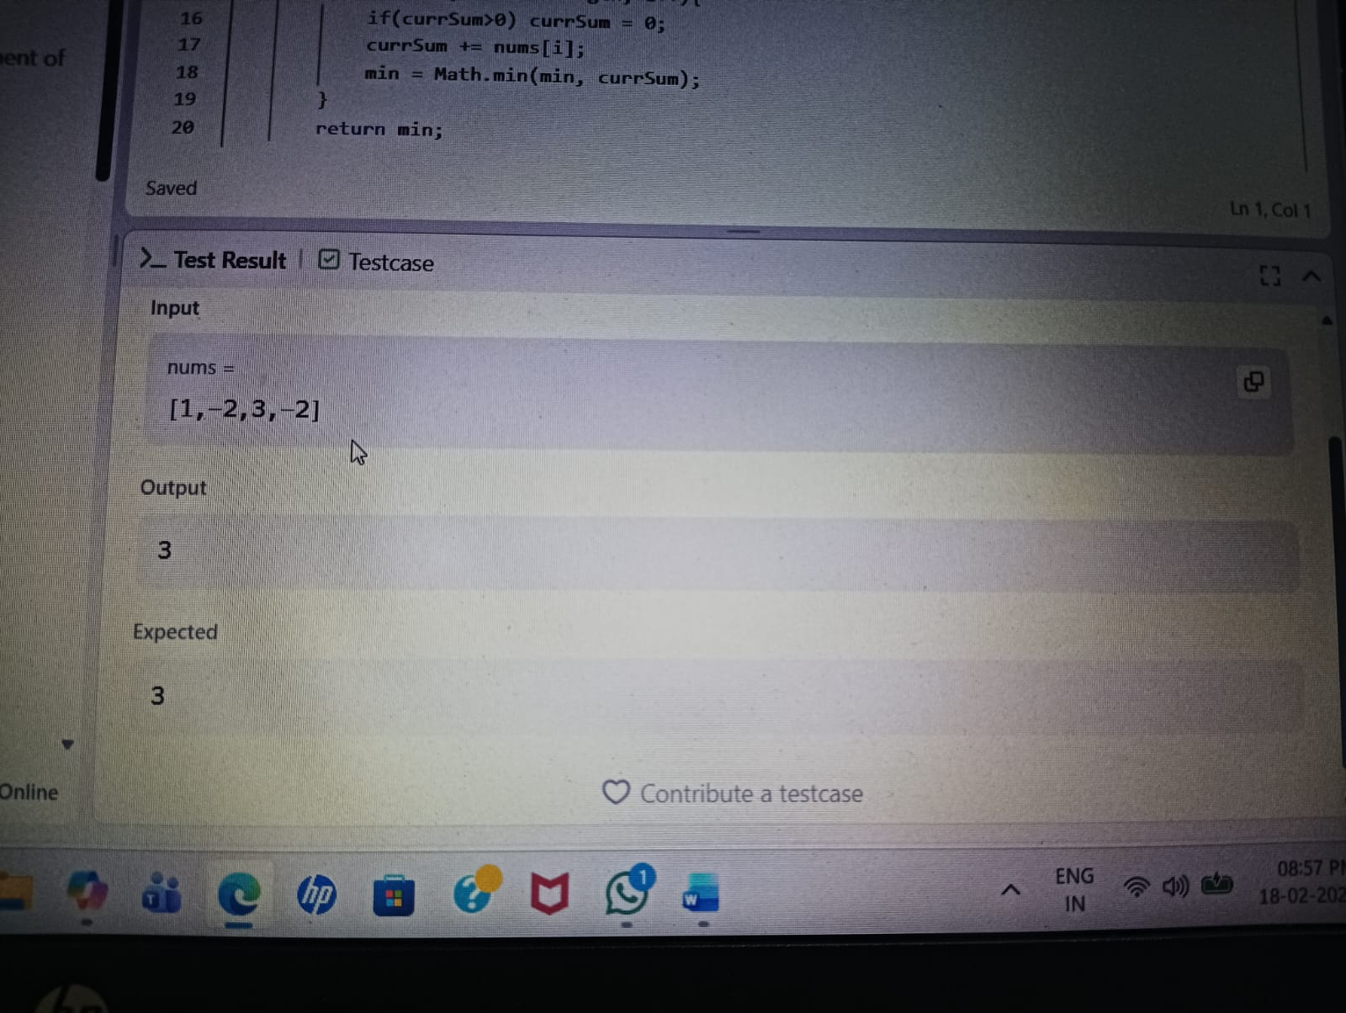
Result: The function returns the maximum possible sum of a subarray, considering both:
- Normal contiguous subarray
- Circular subarray (wrapping from end to beginning)
Task5:
Aim: To convert a given string into a 32-bit signed integer (like the C/C++ atoi function), handling:
- Leading spaces
- Optional sign (+ or -)
- Numeric characters
- Overflow conditions
Algorithm:
- nitialize variables:
  - i = 0 (index pointer)
  - sign = 1 (default positive)
  - num = 0 (store number as long to handle overflow)
- Skip Leading Spaces
  - Move index i forward while character is ' '.
- Check Sign
  - If current character is '-', set sign = -1.
  - If '+', keep sign = 1.
  - Move to next character.
- Convert Digits
  - While character is between '0' and '9':
    - num = num * 10 + (digit value)
    - Check overflow:
      - If sign == 1 and num > Integer.MAX_VALUE, return Integer.MAX_VALUE
      - If sign == -1 and -num < Integer.MIN_VALUE, return Integer.MIN_VAlue

Program:
class Solution {
public int myAtoi(String s) {
int i = 0, sign = 1;
long num = 0;
while (i < s.length() && s.charAt(i) == ' ') i++;
if (i < s.length() && (s.charAt(i) == '-' || s.charAt(i) == '+')) {
sign = (s.charAt(i) == '-') ? -1 : 1;
i++;
}
while (i < s.length() && s.charAt(i) >= '0' && s.charAt(i) <= '9') {
num = num * 10 + (s.charAt(i) - '0')
if (sign == 1 && num > Integer.MAX_VALUE)
return Integer.MAX_VALUE;
if (sign == -1 && -num < Integer.MIN_VALUE)
return Integer.MIN_VALUE;
i++;
}
return (int) (num * sign);
}
}

Output:
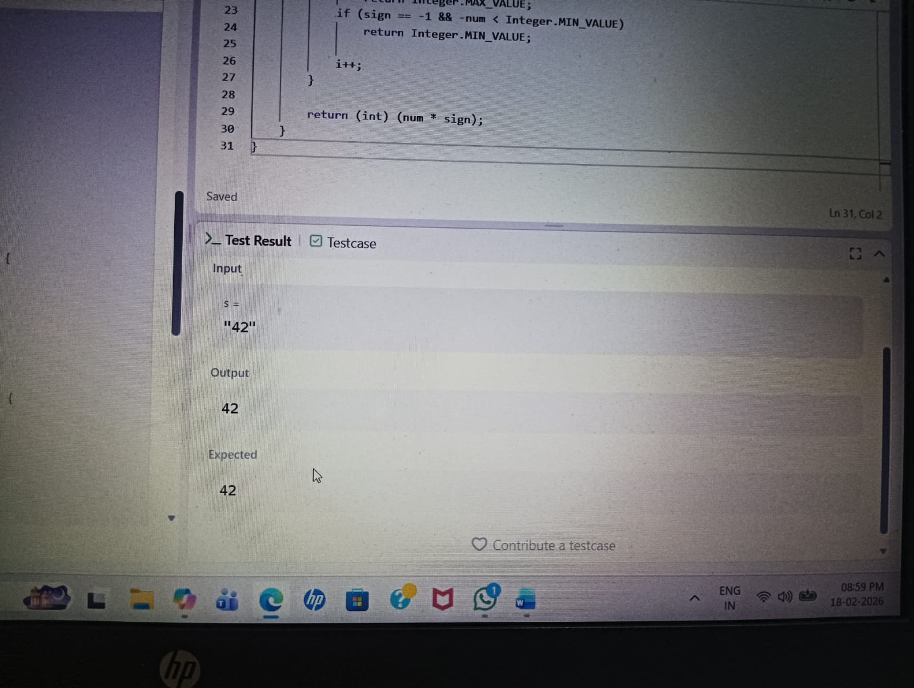

Result: The function returns the converted integer after handling:
- Invalid characters (ignored after digits stop)
- Leading spaces
- Positive/Negative sign
- Overflow cases

Task6:
Aim:
To determine the minimum number of deletions required in a string so that no two adjacent characters are the same (i.e., the string becomes alternating).
Algorithm:
1 Start.
2 Input:
- q → number of test cases.
3 For each test case:
- Read string s.
- Initialize deletions = 0.
4 Traverse the string from index 1 to s.length() - 1:
- If s.charAt(i) == s.charAt(i - 1),
  - Increment deletions.
5 After traversal, print deletions.
6 Repeat for all test cases.
7 Stop.
Program:
import java.util.*;
public class AlternatingCharacters {
static int alternatingCharacters(String s) {
int deletions = 0;
for (int i = 1; i < s.length(); i++) {
if (s.charAt(i) == s.charAt(i - 1)) {
deletions++;
}
}
return deletions;
}
public static void main(String[] args) {
Scanner scanner = new Scanner(System.in);
int q = scanner.nextInt(); // number of queries
while (q-- > 0) {
String s = scanner.next();
int result = alternatingCharacters(s);
System.out.println(result);
}
scanner.close();
}
Output: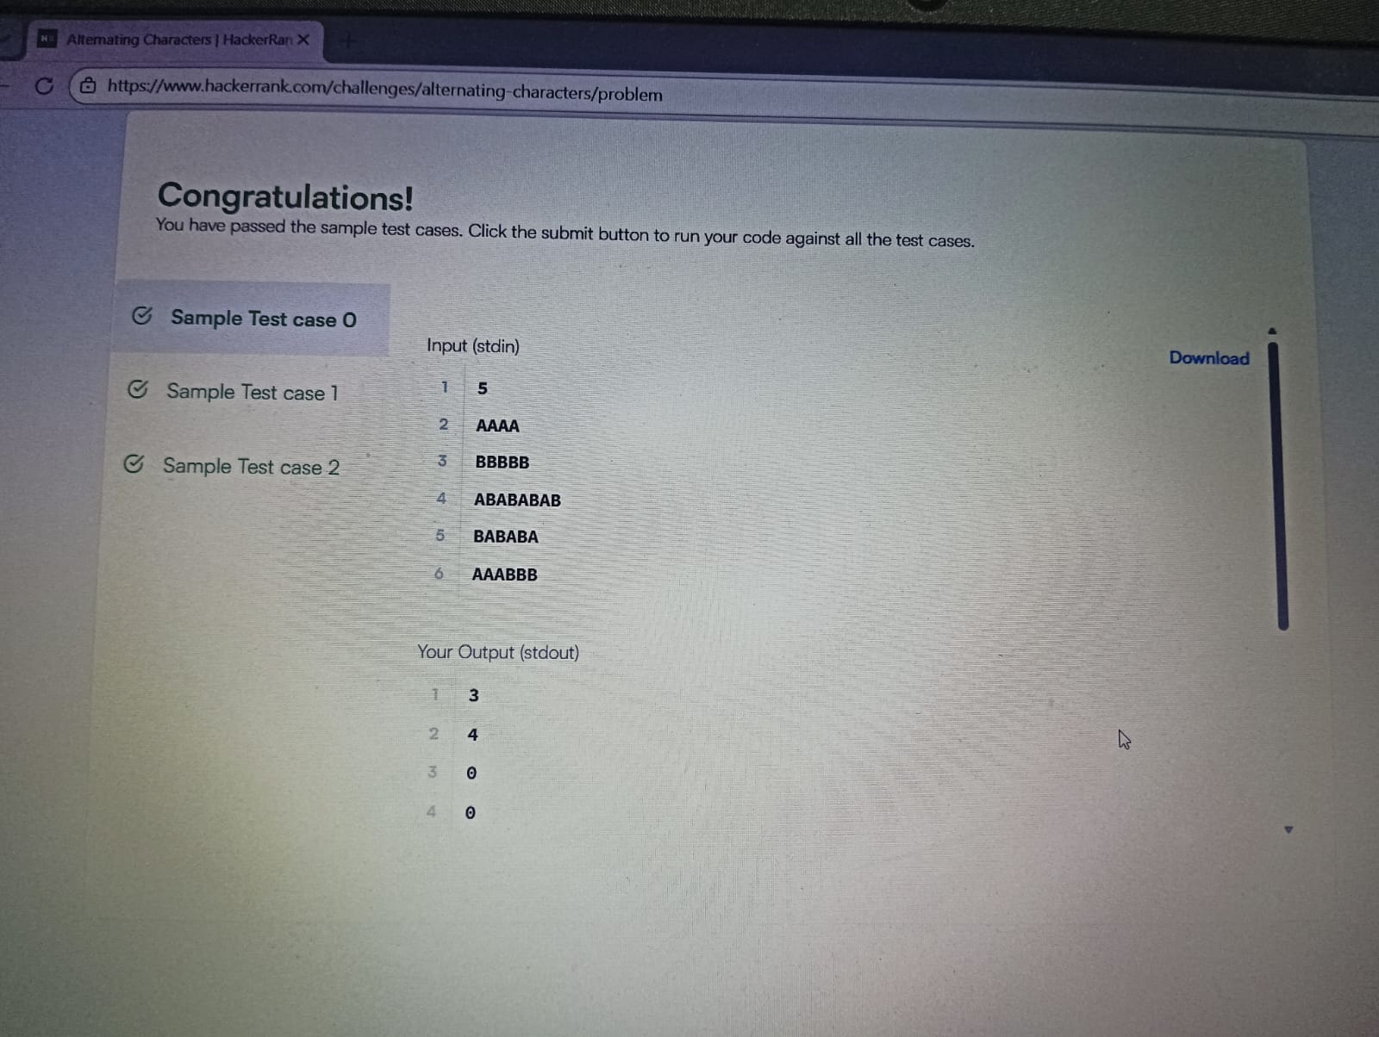

Result:The program prints the minimum number of deletions required to make the string alternating.
Task7:
Aim: To find the length of the longest substring without repeating characters using the Sliding Window technique.
Algortihm:
1 Initialize:
- i = 0 (start of window)
- j = 0 (end of window)
- max = 0 (maximum length found)
- Create a HashMap<Character, Integer> to store character frequencies
2 While j < s.length():
- Add s.charAt(j) to the map and increase its count.
3 Check conditions:
- If map.size() == j - i + 1
→ All characters in the current window are unique.
→ Update max = max(max, window size)
→ Move j++.
- If map.size() < j - i + 1
→ Duplicate exists in window.
→ Shrink window from left:
  - Reduce frequency of s.charAt(i)
  - Remove it if frequency becomes 0
  - Increment i
→ Repeat until window becomes valid
→ Then move j++.
4 Return max.
Program:
class Solution {
public int lengthOfLongestSubstring(String s) {
Map<Character, Integer> map = new HashMap<>();
int i = 0;
int j = 0;
int max = 0;
while(j < s.length()){
map.put(s.charAt(j), map.getOrDefault(s.charAt(j), 0) + 1);
if(map.size() == j - i + 1){
max = Math.max(max, j - i + 1);
j++;
}
else if(map.size() < j - i + 1){
while(map.size() < j - i + 1){
map.put(s.charAt(i), map.get(s.charAt(i)) - 1);
if(map.get(s.charAt(i)) == 0) map.remove(s.charAt(i));
i++;
}
j++;
}
}
return max;
}
}

Output:
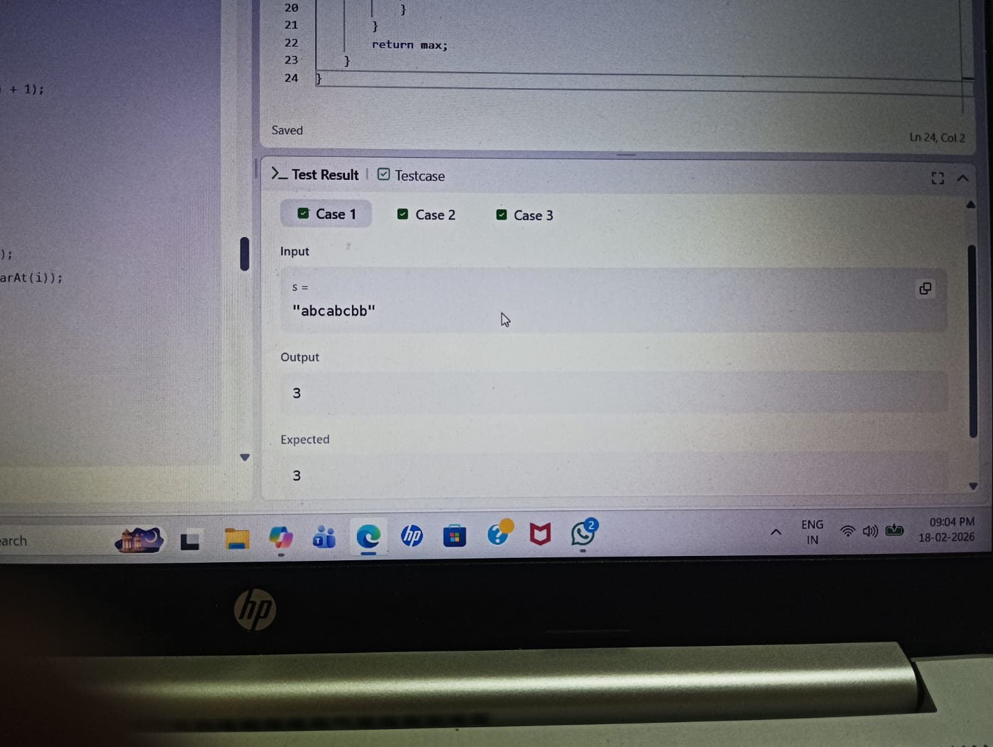

Result: The function returns the length of the longest substring without repeating characters.

Task8:
Aim: To find all words in the given array that match a specified pattern, where there is a one-to-one mapping between characters of the word and the pattern.
Algorithm:
- Create an empty list res to store matching words.
- For each word in the words array:
  - Call the check(word, pattern) function.
  - If it returns true, add the word to res.
- Return the list res.
Program:
class Solution {
public List<String> findAndReplacePattern(String[] words, String pattern) {
List<String> res = new ArrayList<>();
for (String word : words) {
if (check(word, pattern)) res.add(word);
}
return res;
}
boolean check(String a, String b) {
for (int i = 0; i < a.length(); i++) {
if (a.indexOf(a.charAt(i)) != b.indexOf(b.charAt(i))) return false;
}
return true;
}
}

Output:
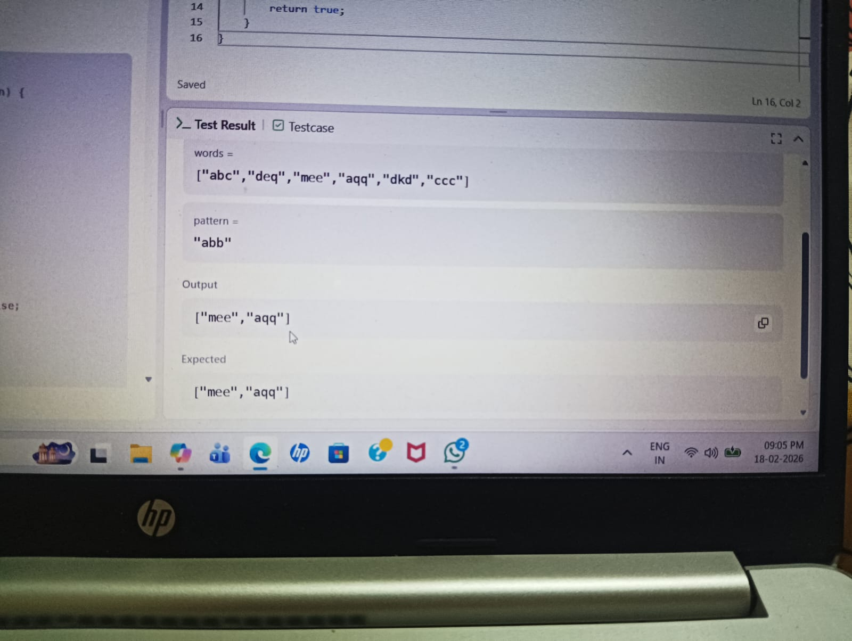

Result: The function returns a list of words that follow the same character pattern as the given pattern string.

Task9:
Aim: To find all strings in the given array that are substrings of another word in the same array.
Algorithm:
1 Let n be the number of words.
• Create an empty list ans to store matching words.
2 Use two nested loops:
- Outer loop (i) from 0 to n-1.
- Inner loop (j) from 0 to n-1.
3 For each pair (i, j):
- If i != j and words[j].contains(words[i]):
  - Add words[i] to ans.
  - Break inner loop (no need to check further).
4 Return ans.
Program:
import java.util.*;
class Solution {
public List<String> stringMatching(String[] words) {
int n = words.length;
List<String> ans = new ArrayList<>();
for (int i = 0; i < n; ++i) {
for (int j = 0; j < n; ++j) {
if (i != j && words[j].contains(words[i])) {
ans.add(words[i]);
break;
}
}
}
return ans;
}
}
Output:
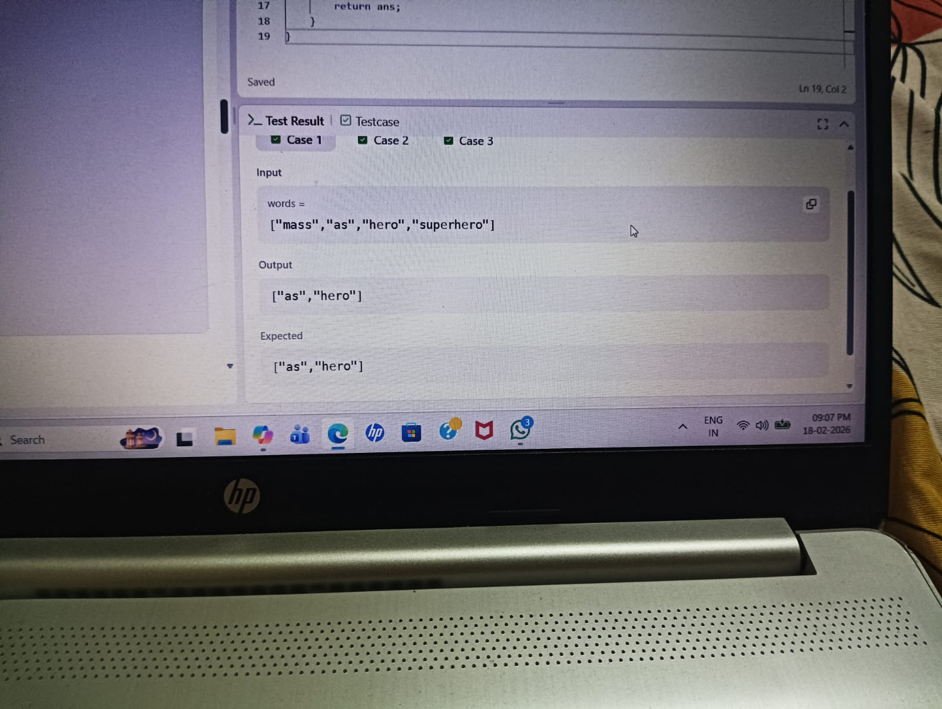

Result: The function returns a list of words that appear as a substring of another word in the array.

